# Overview

This document logs the step-by-step operations while setting up System Prototype on CentOS

NOTE:

1. Please refer to the “Dependencies” in the “Overview of the current infrastructure” to check any prerequisite for installation.

# Prerequisite recheck

1. Install all those dependencies
2. Setup Risk Prediction Engine REST API - refer to Risk Prediction Server guildline
3. Setup NodeJS scripts for mongoDB connection - refer to NodeJS guideline
4. Upload BPMN diagrams via activiti-explorer - refer to Activiti guideline
5. Add a ReadWrite user for system prototype on MongoDB - refer to MongoDB guideline
6. Import demo data to OrientDB - refer to OrientDB guideline
7. (Optional) Add rule to KIE-DROOLS - refer to KIE-DROOLS guideline

# Additional Operations

1. With all the names and IDs of the BPMN diagrams which have been uploaded to Activiti, modify the following code, which is located in

“Main system prototype” -> “model_api_server” -> “Workflow.js” -> line#2-#9

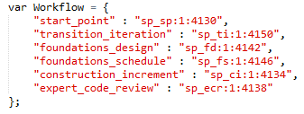

1. If we are setting up a new server instance, modify “./control/config.js” with new ip address to each data resource.
2. Deploy the source code to tomcat, for example, the current prototype is at <http://ec2-54-67-99-52.us-west-1.compute.amazonaws.com:8686/demo/phase5/start/factorsInputPage.html>
3. Refer to “User Manual” to learn about the features in the current prototype.